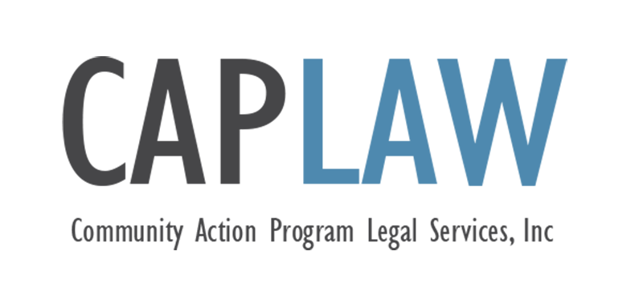
Medical Exemption Request – COVID-19 Vaccine
This sample form was developed by Community Action Program Legal Services, Inc. (“CAPLAW”) and has not been approved by any outside authority, such as the U.S. Department of Health and Human Services. When using this sample, CAPLAW strongly recommends you consult with counsel familiar with your CAA’s operations and the laws of your state.

This publication is part of the Community Services Block Grant (CSBG) Legal Training and Technical Assistance Center. It was created by CAPLAW in the performance of the U.S. Department of Health and Human Services, Administration for Children and Families, Office of Community Services Cooperative Agreement – Grant Award Number 90ET0467-03-C3. Any opinion, findings, conclusions, or recommendations expressed in this material are those of the author(s) and do not necessarily reflect the views of the U.S. Department of Health and Human Services, Administration for Children and Families.

The contents of this publication are intended to convey general information only and do not constitute legal advice. This publication does not constitute or create an attorney-client relationship. If you need legal advice, please contact CAPLAW or another attorney directly.

[Template] REQUEST FOR A MEDICAL EXEMPTION FROM THE COVID-19 VACCINATION REQUIREMENT
[CAA] policy requires [all CAA employees] to be vaccinated against COVID-19, with exceptions only as required by law. We are committed to providing equal employment opportunities for all in a workplace free from harassment, discrimination, and retaliation.
Requests for “medical accommodation” or “medical exemption” will be treated as requests for a disability accommodation and evaluated and decided under the Americans with Disabilities Act (ADA) and applicable state laws. To seek a medical exemption from the COVID-19 vaccination requirement due to a disability, please complete Part 1 of the form below. Please ask your medical provider (a physician, nurse practitioner, physician’s assistant, or other provider approved by [Human Resources]) to complete Part 2 of the form. Return both Part 1 and Part 2 to [Human Resources]. We may also request other information, as needed. Part 3 of this form is for internal [Human Resources] use only.
[CAA] will use the information provided to engage in a series of conversations with you to determine the limitations of your disability and explore potential reasonable accommodations that could overcome those limitations. Failure to provide the information requested in Parts 1 and 2 of this form may limit our ability to understand your request and to fully engage in this interactive process.
During the interactive process, we encourage you to suggest specific accommodations that you believe would allow you to perform your job. However, [CAA] is not required to make any specific accommodation requested by you. We may provide an alternative accommodation, or we may deny an accommodation if it would impose an undue hardship on [CAA] or if there is a direct threat to the health and safety of [CAA] employees that cannot be mitigated by a reasonable accommodation.
[CAA] is required to keep any medical information you provide confidential, subject to the applicable ADA standards. All medical information received as a result of the reasonable accommodation process will be maintained in a separate medical file apart from your personnel file.
Signing this form constitutes a declaration that the information you provide is complete and accurate, to the best of your knowledge. Any intentional misrepresentation to [CAA] may result in disciplinary action, including termination.

Part 1 – To Be Completed by the Employee
Request for COVID-19 Vaccine Exemption
Employee Name:
Date of Request:
Department:
Position:
Supervisor:
Phone Number:
Medical or Disability Exemption Request:
I am requesting a medical exemption to the requirement for COVID-19 vaccination because of a disability. I understand that my request for accommodation may not be granted if it is not reasonable, if it poses a direct threat to the health or safety of others in the workplace or to me, or if it creates an undue hardship for [CAA]. I declare that the information I have provided in connection with this request is complete and accurate to the best of my knowledge.

Employee Name:
Employee Signature:
Date:

Part 2 – To be Completed by the Employee’s Medical Provider
Employee Name:
Medical Certification for COVID-19 Vaccine Exemption
Dear Medical Provider:
[CAA] requires its employees to be fully vaccinated against COVID-19. The individual named above is seeking a medical exemption from the requirement for COVID-19 vaccination. Please complete this form to assist [CAA] in its reasonable accommodation process. If you have questions about completing this form, please contact [CAA] at [email and phone number].
Please provide the following information, where applicable:
- The applicable contraindication or precaution for COVID-19 vaccination, and for each contraindication or precaution, indicate: (a) whether it is recognized by the CDC pursuant to its guidance; and (b) whether it is listed in the package insert or Emergency Use Authorization fact sheet for each of the COVID-19 vaccines authorized or approved for use in the United States;

- A description of the individual’s condition and medical circumstances and why COVID-19 vaccination is not considered safe. Where applicable, please indicate the specific nature and probable duration of the medical condition or circumstances that contraindicate immunization with a COVID-19 vaccine or might increase the risk for a serious adverse reaction; and

- Any other medical condition that would limit the employee from receiving a COVID-19 vaccine.

Medical Provider Name/Title:
Medical Provider Signature:
Date:
Part 3 – To be Completed by [Human Resources Staff]
Request for COVID-19 Vaccine Exemption
Employee Name:
Date Request Form Received:
Description of Interactive Process (include dates of meetings/conversations, documentation provided by the employee, descriptions of any accommodations discussed, and why they were accepted or rejected):

Exemption/Accommodation granted? □ Yes □ No
Describe Exemption/Accommodation:

If exemption/accommodation granted, list alternative safety precautions required:

If exemption/accommodation not granted, explain why:

Staff Name:
Staff Signature:
Date:

